Assignment 02 for MSS301 - Watch Management using Saga Pattern

1. Introduction
In this Assignment, you will build a microservices-based system for a watch store. The primary challenge is to maintain data consistency across different services without using traditional distributed transactions (like two-phase commit), which are often unsuitable for a microservices architecture.
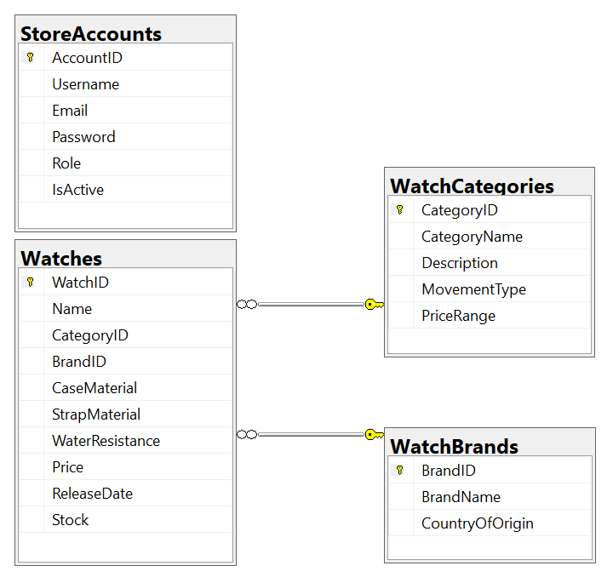
- Projects in IntelliJ IDEA:
  - MSAccount_StudentCode: Manages user accounts (StoreAccounts table).
  - MSBrand_StudentCode: Manages watch brands (WatchBrands table).
  - MSWatch_StudentCode: Manages watch products and categories (Watches, WatchCategories tables).
  - APIGateway_StudentCode: Acts as the single entry point for all client requests, routing them to the appropriate microservice.
- MS SQL Databases:
  - You will use JPA/Hibernate with a code-first approach. This means you will define your data models as Java @Entity classes, and Hibernate will automatically generate the database schema (tables, columns, relationships) for you upon application startup.
  - DBAccount: Will contain the StoreAccounts table.
  - DBBrand: Will contain the WatchBrands table.
  - DBWatch: Will contain the Watches and WatchCategories tables.
Each microservice will connect only to its own dedicated database, ensuring true service independence.

Table data type
StoreAccounts
Column Name | Data Type | Description
AccountID | INT (Primary Key) | Unique identifier for each system account.
Username | VARCHAR(20) NOT NULL | Login username for the account.
Email | VARCHAR(100) NOT NULL | Email address associated with the account.
Password | VARCHAR(100) NOT NULL | The password associated with the account.
Role | int | User role (e.g., Administrator (1), Staff (2), Member (3)).
IsActive | BOOLEAN DEFAULT TRUE | Indicates if the account is active (TRUE/FALSE).

WatchCategories
Column Name | Data Type | Description
CategoryID | INT (Primary Key) | Unique identifier for each watch category.
CategoryName | VARCHAR(100) | Name of the watch category.
Description | TEXT | Short description of the category.
MovementType | VARCHAR(50) | The movement type (e.g Automatic or Quartz or Manual)
PriceRange | VARCHAR(100) | Typical price range (e.g., $10-$50, $50-$100).

Watches
Column Name | Data Type | Description
WatchID | INT (Primary Key) | Unique identifier for each watch.
Name | VARCHAR(255) | Name of the watch.
CategoryID | INT (Foreign Key) | Links to WatchCategories(CategoryID).
BrandID | INT (Foreign Key) | Links to WatchBrand(BrandID).
CaseMaterial | VARCHAR(100) | Case material.
StrapMaterial | VARCHAR(100) | Strap material.
WaterpMaterial | VARCHAR(50) | Water material.
Price | DECIMAL(10,2) | Price of the watch.
ReleaseDate | DATE | Date when the watch was released.
Stock | INT | Number of units available in stock.

WatchBrand
Column Name | Data Type | Description
BrandID | INT (Primary Key) | A unique identifier for each brand.
BrandName | VARCHAR(200) | The name of the brand that produces the watch.
CountryOfOrigin | VARCHAR(50) | The country where the brand originated.

2. Data (must input these information)
StoreAccounts
AccountID | Username | Email | Password | Role | IsActive
1 | adminsys | admin@drawingpen.com.vn | @1 | 1 | 1
2 | staff02 | staff02@drawingpen.com.vn | @1 | 2 | 1
3 | member01 | member01@drawingpen.com.vn | @1 | 3 | 1
4 | member02 | member02@drawingpen.com.vn | @1 | 3 | 0
5 | staff01 | staff01@drawingpen.com.vn | @1 | 2 | 0

WatchCategories
CategoryID | CategoryName | Description | MovementType | PriceRange
1 | Dive Watches | Designed for underwater diving and feature high water resistance. | Automatic | $500 - $10,000
2 | Chronograph Watches | Watches with a stopwatch function in addition to the main display. | Automatic or Quartz | $300 - $8,000
3 | Dress Watches | Elegant and simple, intended to be worn with formal wear. | Automatic or Manual | $400 - $20,000
4 | Digital Watches | Watches with an LCD or LED screen that show time in a digital format. | Quartz | $50 - $500
5 | Pilot Watches | Originally designed for aviators, featuring large, easy-to-read dials. | Automatic | $700 - $15,000

WatchBrands
BrandID | BrandName | CountryOfOrigin
1 | Rolex | Switzerland
2 | Omega | Switzerland
3 | Seiko | Japan
4 | Casio | Japan
5 | TAG Heuer | Switzerland

Watches

WatchID | Name | CategoryID | BrandID | CaseMaterial | StrapMaterial | WaterResistance | Price | ReleaseDate | Stock
1 | Submariner Date | 1 | 1 | Oystersteel | Oystersteel | 300 meters | 9550.00 | 2020-09-01 | 50
2 | Speedmaster Moonwatch Professional | 2 | 2 | Stainless Steel | Stainless Steel | 50 meters | 7200.00 | 2021-01-05 | 75
3 | Presage Cocktail Time | 3 | 3 | Stainless Steel | Leather | 50 meters | 425.00 | 2019-06-01 | 200
4 | G-Shock DW-5600E-1V | 4 | 4 | Resin | Resin | 200 meters | 69.95 | 1996-06-12 | 500
5 | Carrera Calibre Heuer 02 | 2 | 5 | Stainless Steel | Alligator Leather | 100 meters | 5900.00 | 2022-03-30 | 60
6 | Seamaster Diver 300M | 1 | 2 | Stainless Steel | Rubber | 300 meters | 5400.00 | 2018-02-15 | 120
7 | Prospex SPB143 | 1 | 3 | Stainless Steel | Stainless Steel | 200 meters | 1200.00 | 2020-07-01 | 150
8 | Daytona | 2 | 1 | Oystersteel | Oystersteel | 100 meters | 14550.00 | 2016-03-16 | 30
9 | F-91W | 4 | 4 | Resin | Resin | 30 meters | 19.99 | 1989-01-01 | 1000
10 | IWC Pilot's Watch Mark XVIII | 5 | 4 | Stainless Steel | Leather | 60 meters | 4500.00 | 2016-01-18 | 80

2. Assignment Objectives
Implement CRUD actions with Spring Boot Microservices using Saga Pattern and Database per Service.
- List all items in Watches table (the information includes all information in this table, CategoryName from WatchCategories table). Note that, No permissions for this function.

- Check if login successfully with Administrator role, delete the selected item in Watches table with the updating other related Microservices.

- Check if login successfully with Administrator role, add new item with the following requirements:
- The new item will display at the top of the list.
- All fields are required.
- Value for Price >= 100.
- Value for Name is greater than 10 characters.
- Value for ReleaseDate = Current date
And then update other related Microservices.
- Check if login successfully with Administrator role, update the existing item with the requirements are same as add function. And then update other related Microservices.

Design Postman Script components/pages.
- Create Postman Script for testing
- API Gateway - A single entry point for all client requests, routing traffic to the appropriate downstream microservices.
- Microservices
  - AccountService: Manages login process.
  - BrandService: Manages information of brands.
  - Watch Service: Manages watch, which will have a relationship with a brand.

